**PROJECT DEVELOPMENT PHASE**

**SPRINT-2**

|  |  |
| --- | --- |
| Date | 12 November 2022 |
| Team ID | PNT2022TMID00923 |
| Project Name | Signs with Smart Connectivity for Better Road Safety |

**SPRINT-2:**

* In sprint-2, we have developed a python code using random function to generate random values for distance between user and the vehicle ahead.
* We have also implemented a condition such that, if distance is less than 20, then it displays a warning like “STOP”. The user can either try with different direction or can take diversion
* This helps in reducing accidents ,to avoid clashes and to promote safe driving experience.

**PYTHON CODE:**

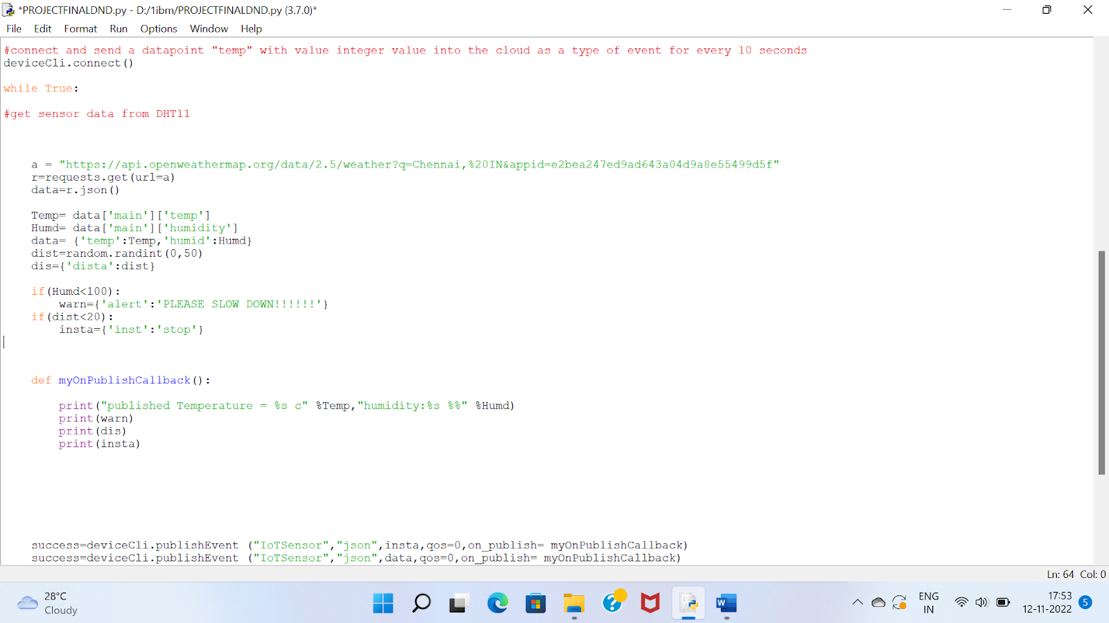



**IBM IoT WATSON PLATFORM:**

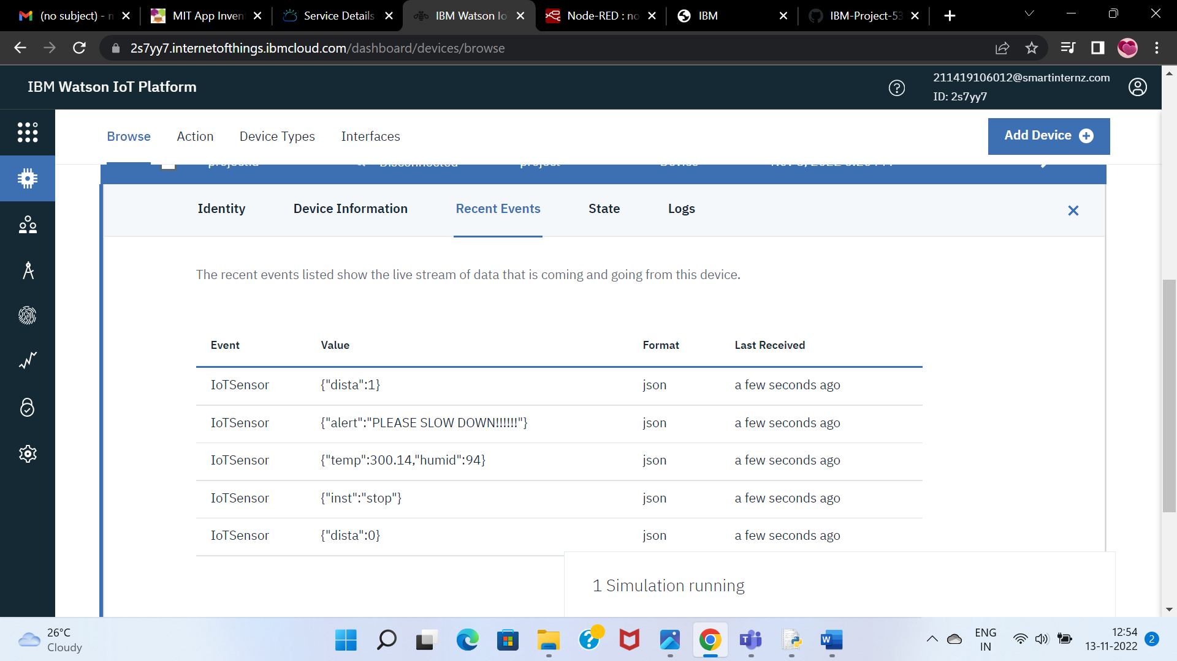

**NODE-RED:**

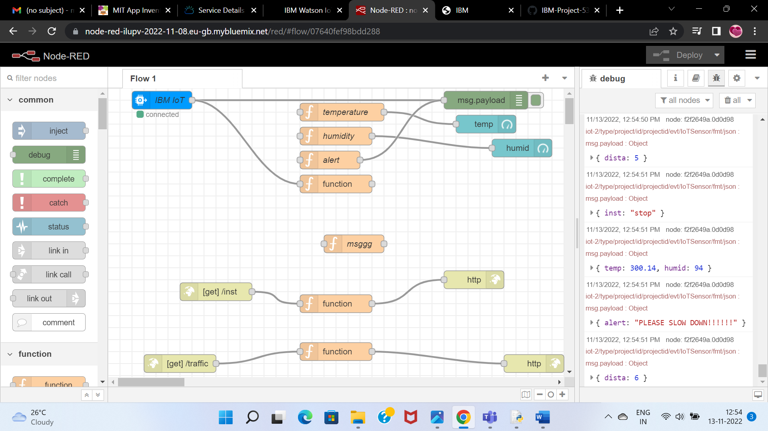

**MIT APP INVENTOR:**

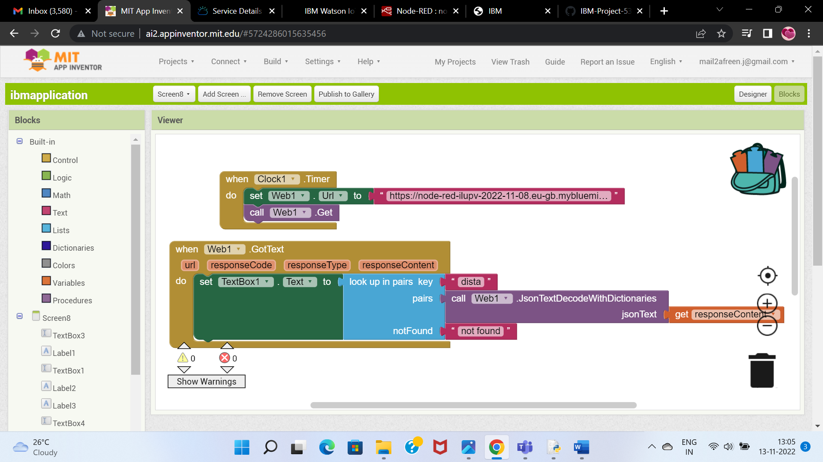

**USER APP SCREENSHOT:**

